CS5551 Advanced Software Engineering

Lab 7

**Name**: Srichakradhar Reddy (32), Sathwik (5)

**Lab ID**: 1_2

1. Launch a new instance in AWS

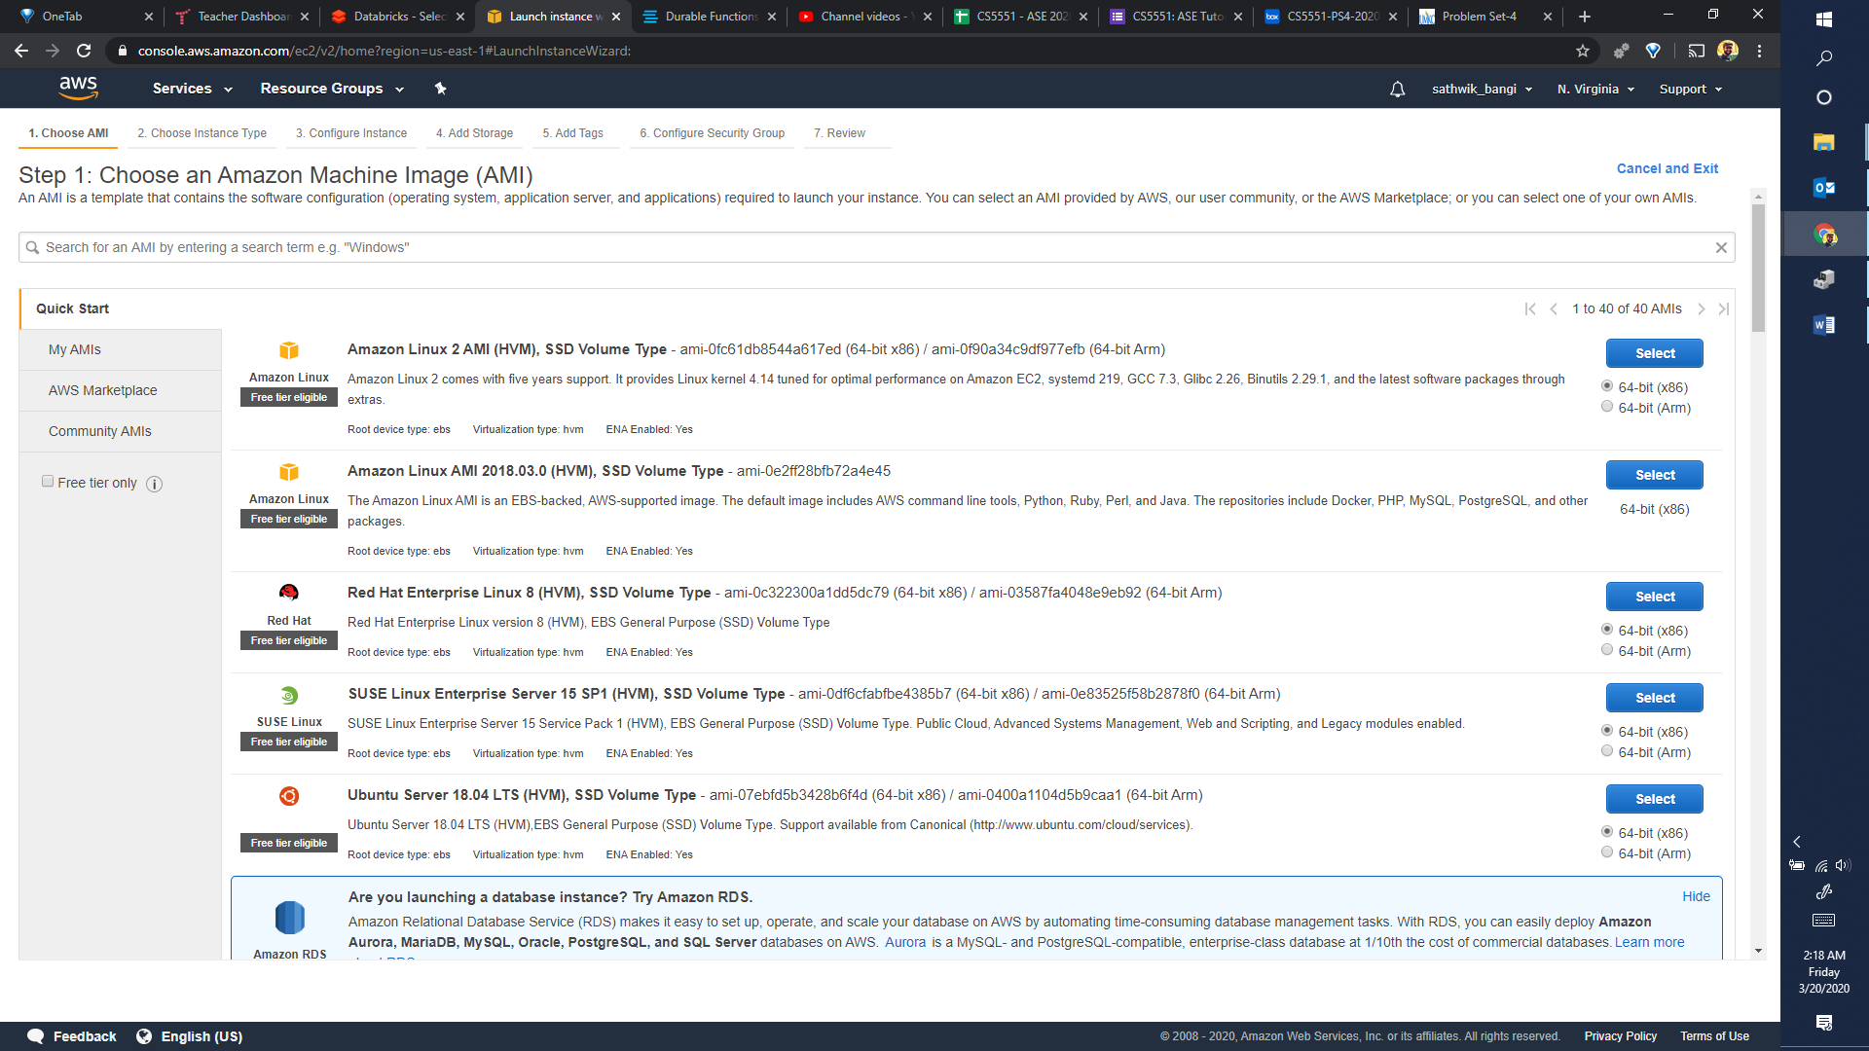

1. Choose Ubuntu 18.04 LTS Server

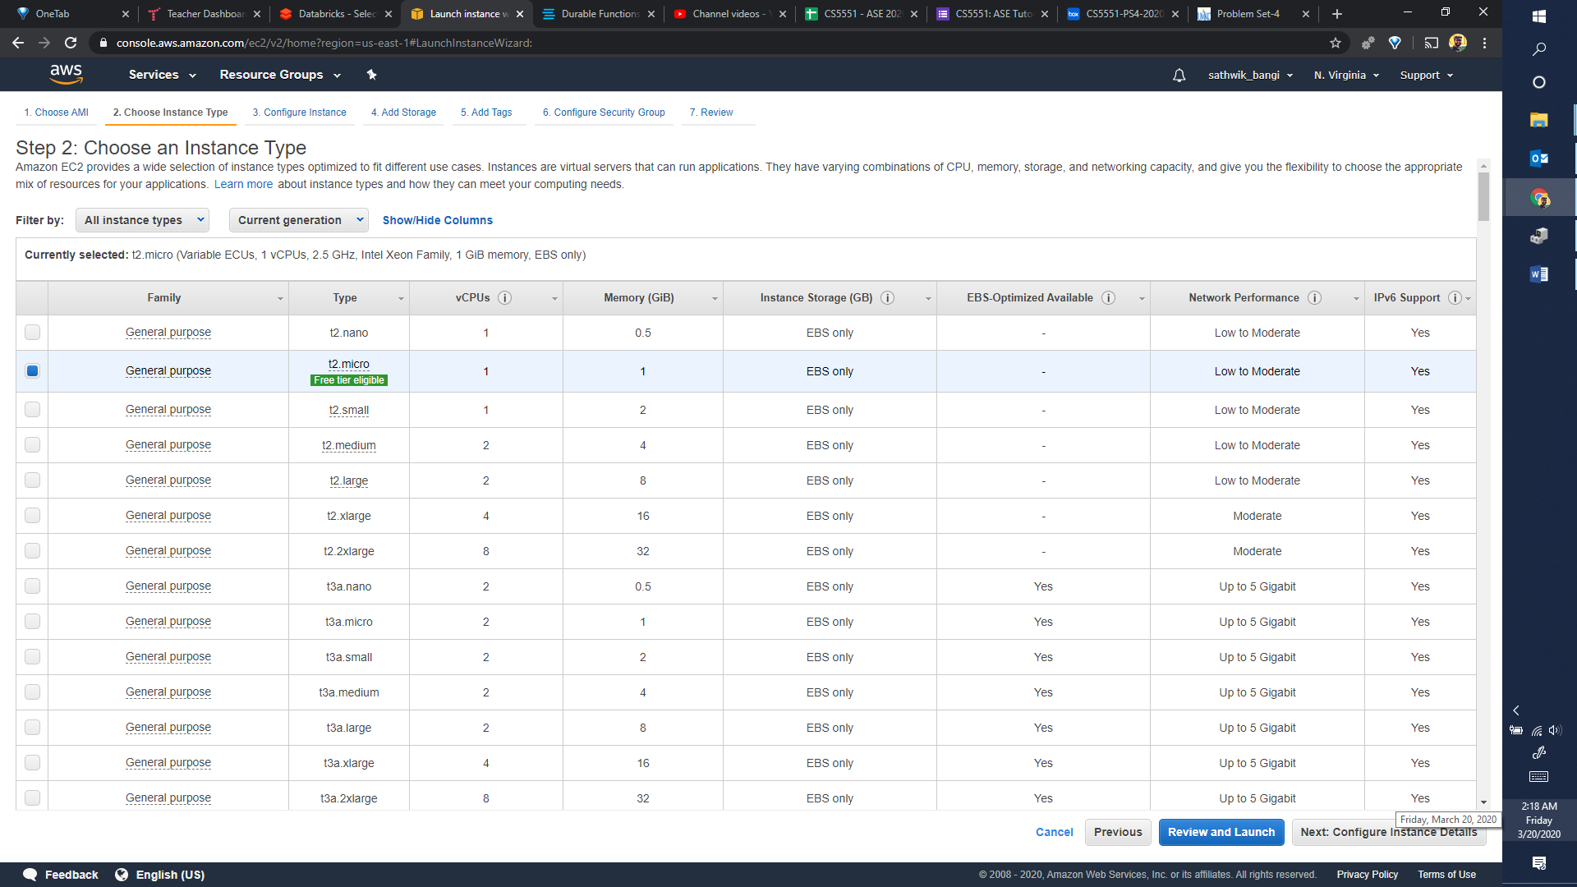

1. Choose free tier eligible t2-micro general purpose VM
2. Click on “Review and Launch”
3. Wait for the instance to be provisioned and then connect with PuTTY

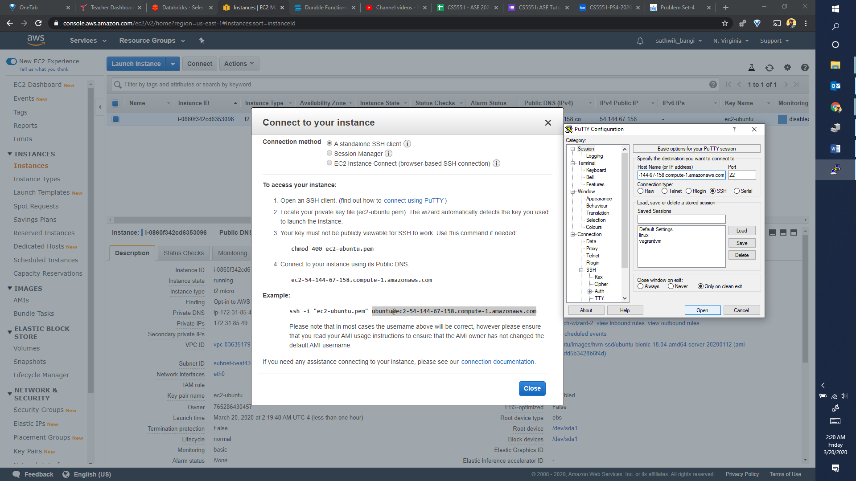6. You will be presented with a ubuntu shell

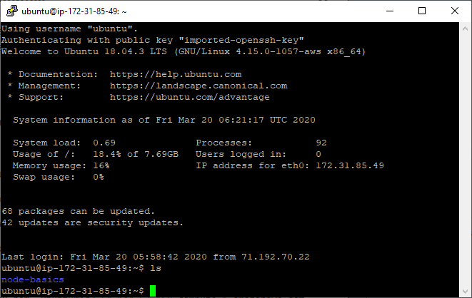

1. Clone a basic node server from github
2. Install pm2 from npm to run server in the background

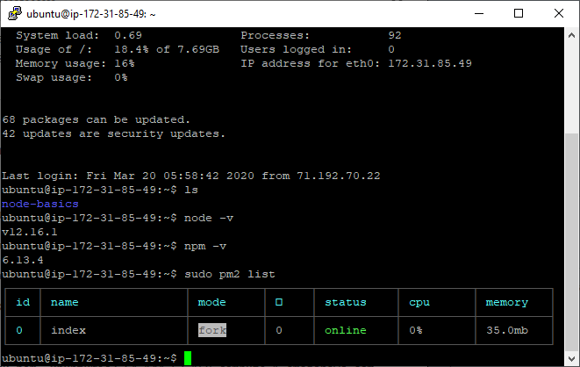

1. Add port 8080 to inbound rules to allow inbound connections to the server.

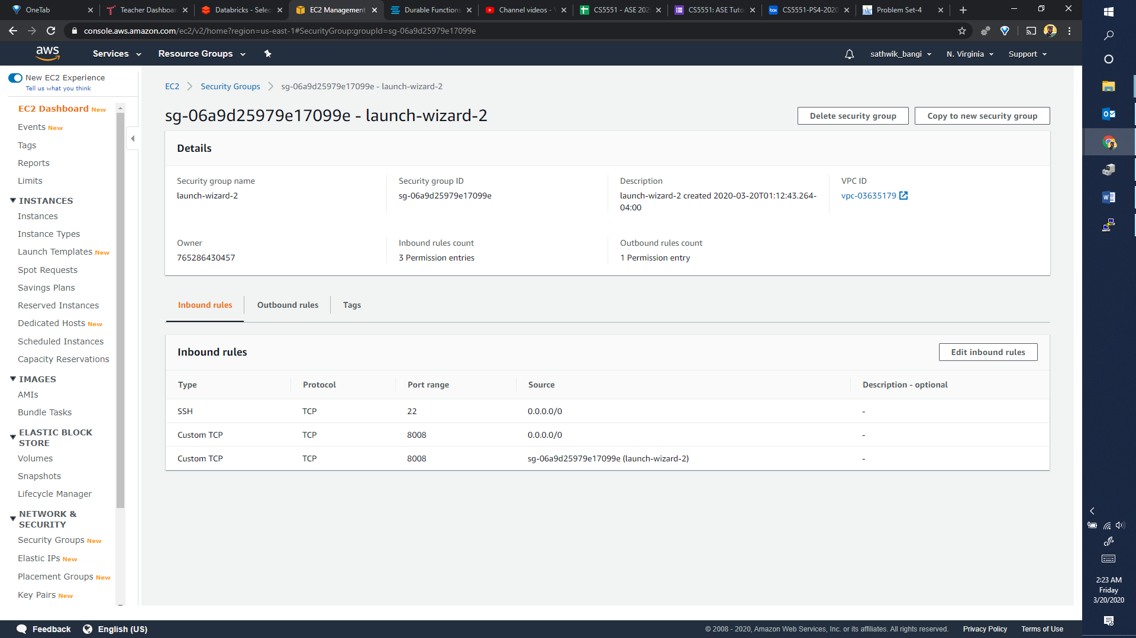

1. Now, we can connect from the internet on port 8008

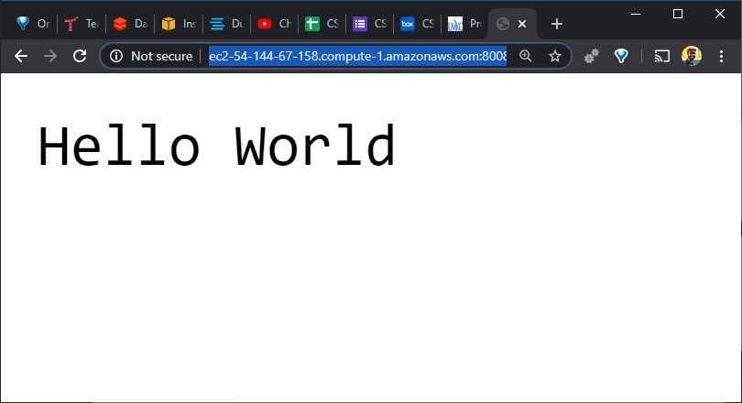

1. The server keeps running if sudo pm2 startup is used.